**Lecture 4**

1. Imagine asking a random sample of 60 students from your school about their birth months. Should you use a bar graph or a histogram to display the data?
2. Bar Graph
3. Histogram
4. Do students who graduate from high school earn more money than students who do not? To find out, we took a random sample of 371 U.S. residents aged 18 and older. The educational level and total personal income of each person were recorded. The data for the 57 non-graduates (No) and the 314 graduates (Yes) are displayed in the relative frequency histograms.

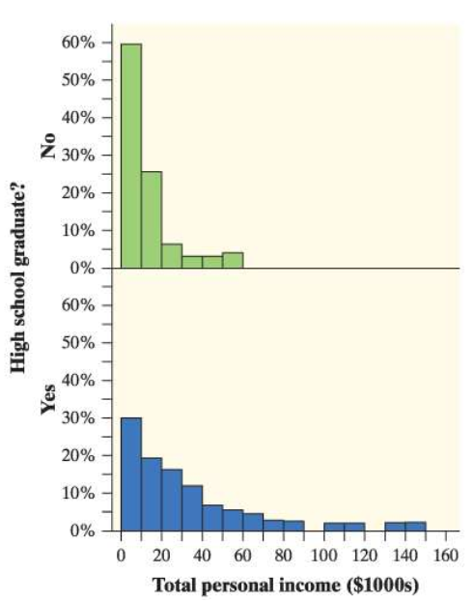

Would it be appropriate to use frequency histograms instead of relative frequency histograms in this setting? Explain why or why not.

1. Feeling sleepy? Students in a high school statistics class responded to a survey designed by their teacher. One of the survey questions was “How much sleep did you get last night?” Here are the data (in hours):

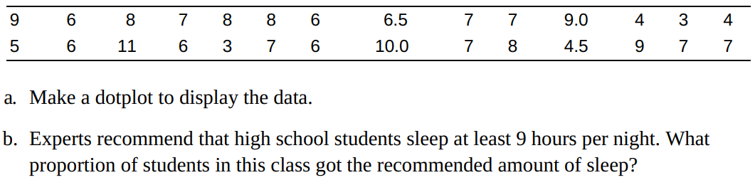

1. Here are the weights (in grams) of 17 Snickers Fun Size bars from a single bag:  
   17.1 17.4 16.6 17.4 17.7 17.1 17.3 17.7 17.8 19.2 16.0 15.9 16.5 16.8 16.5 17.1 16.7

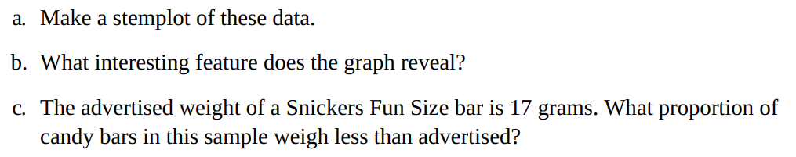

1. Carbon dioxide emissions Burning fuels in power plants and motor vehicles emits carbon dioxide (CO2), which contributes to global warming. The table displays CO2 emissions per person from countries with populations of at least 20 million. Make a histogram of the data using intervals of width 2, starting at 0.

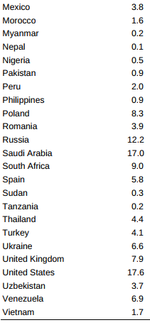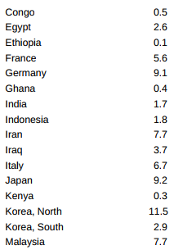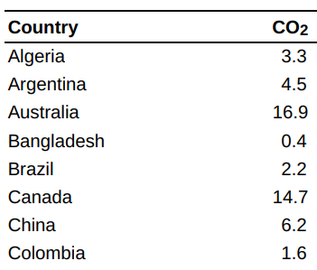

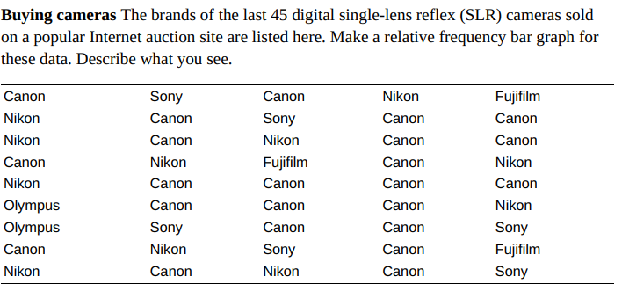**Lecture 5**

1. 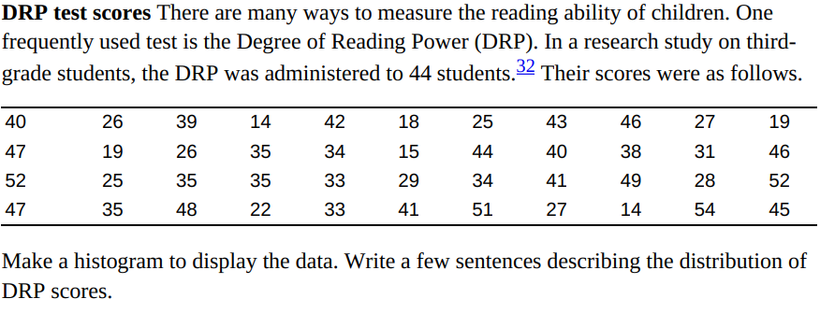
2. 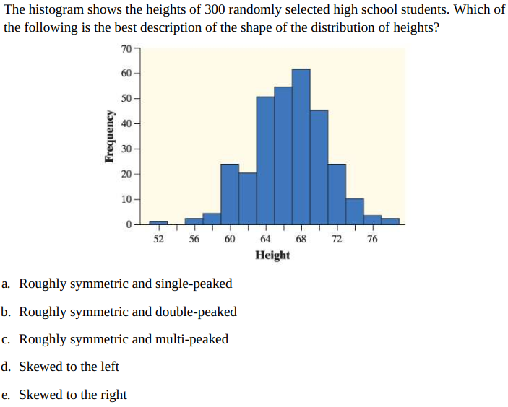
3. 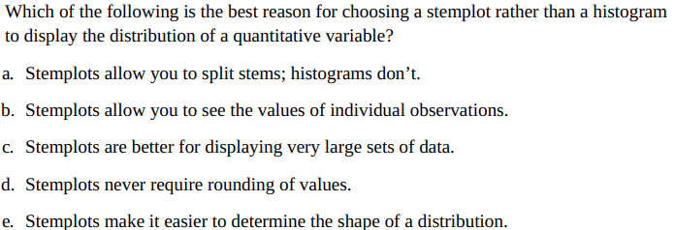

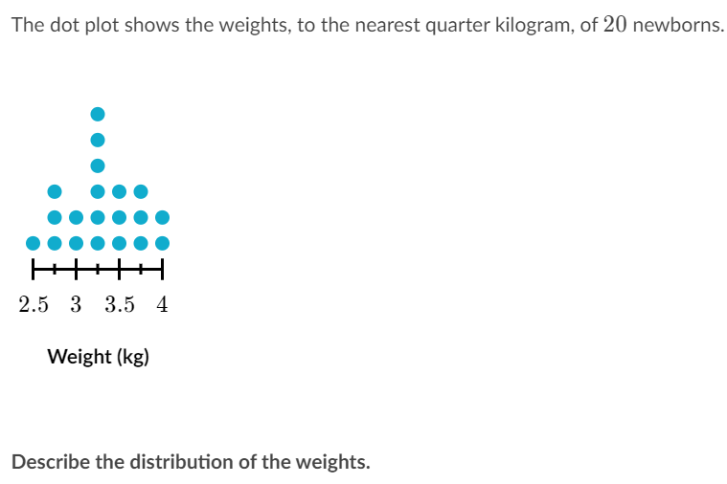

1. The dot plot shows the weights, to the nearest quarter kilogram, of 20 newborns.

Describe the distribution of the weights.(Tips: shape, center, spread, outliers.)

1. In the state of Connecticut, the Department of Motor Vehicles (DMV) requires 16- and 17-year-olds to take a 25-question knowledge test in order to obtain a Learner's Permit. To pass, prospective drivers must correctly answer at least 20 questions. On one Monday, 22 teenagers took the test. The dot plot below shows their scores. Describe the distributionof the students’ test scores

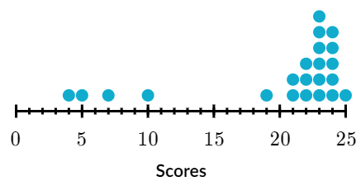

1. Chad recorded the results from 60 rolls of a single 6-sided die. Describe the distribution of the number of rolls.

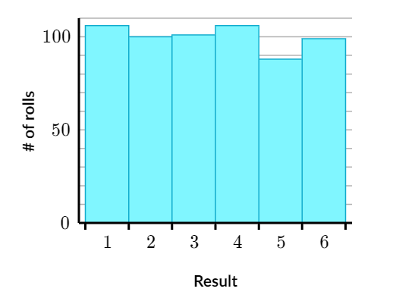

**Lecture 6**

1. 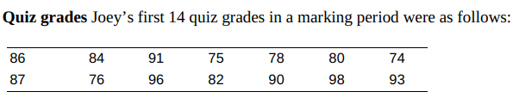
2. Calculate the mean. Show your work.
3. Suppose Joey has an unexcused absence for the 15th quiz, and he receives a score of 0. Recalculate the mean. What property of the mean does this illustrate?
4. 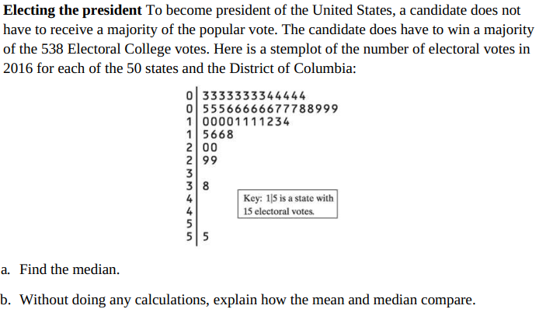
5. Here are the foot lengths (in centimeters) for a random sample of seven 14-year-olds from the United Kingdom: 25 22 20 25 24 24 28  
   Calculate the standard deviation. Interpret this value.

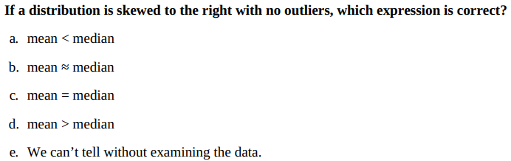

**Lecture 7**

1. According to a study by Nielsen Mobile, “Teenagers ages 13 to 17 are by far the most prolific texters, sending 1742 messages a month.” Mr. Williams, a high school statistics teacher, was skeptical about the claims in the article. So he collected data from his first-period statistics class on the number of text messages they had sent in the past 24 hours. Here are the data:  
   0 7 1 29 25 8 5 1 25 98 9 0 26  
   8 118 72 0 92 52 14 3 3 44 5 42  
   a. Make a boxplot of these data.  
   b. Use the boxplot you created in part (a) to explain how these data seem to contradict the claim in the article

1. 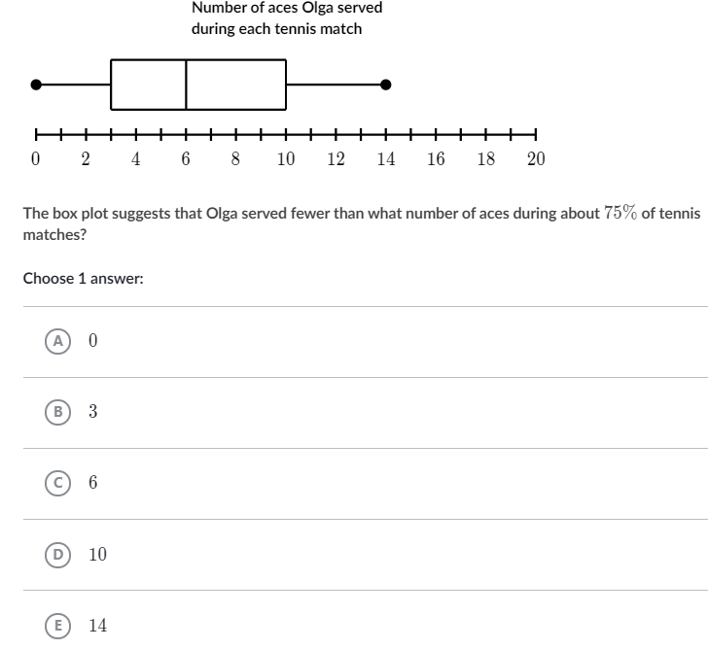
2. How many pairs of shoes does a typical teenage boy own? To find out, two AP® Statistics students surveyed a random sample of 20 male students from their large high school and recorded the number of pairs of shoes that each boy owned. Here are the data, along with a dotplot:  
   14 7 6 5 12 38 8 7 10 10 10 11 4 5 22 7 5 10 35 7

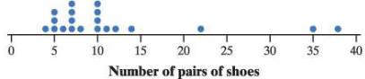

Find the interquartile range.